How to append multiple values without using append and extend methods?
This can be done using slice operator.
Syntax: list-name[len(list-name):]=iterable/collection

Example:
>>> A=[10,20,30]
>>> print(A)
[10, 20, 30]
>>> A[3:]=[40,50,60]
>>> print(A)
[10, 20, 30, 40, 50, 60]
>>> A[6:]=[1,2]
>>> print(A)
[10, 20, 30, 40, 50, 60, 1, 2]
>>> A[len(A):]=[100,200,300]
>>> print(A)
[10, 20, 30, 40, 50, 60, 1, 2, 100, 200, 300]

Update or Replace values of List
Replacing or updating values of list is done in different ways
- Using index
- Using slicing
Using index
Using index only one value can be replaced

Syntax: list-name[index]=value

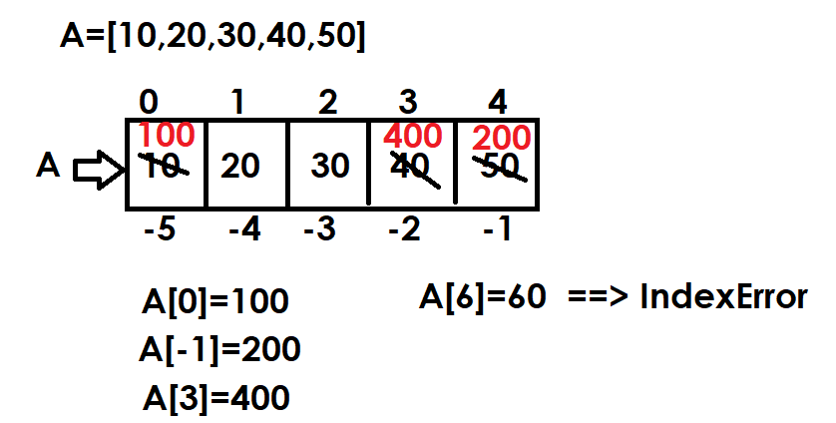
Example:
A=[10,20,30,40,50]
print(f'Before Replacing {A}')
A[0]=100
print(f'After Replacing {A}')
A[-1]=200
print(f'After Replacing {A}')
A[3]=400
print(f'After Replacing {A}')
#A[6]=600

Output
Before Replacing [10, 20, 30, 40, 50]
After Replacing [100, 20, 30, 40, 50]
After Replacing [100, 20, 30, 40, 200]
After Replacing [100, 20, 30, 400, 200]

Example:
# Write a program to swap first and last elements/values in a
# given list

A=[10,20,30,40,50]

print(f'Before Swaping Elements {A}')
temp=A[0]
A[0]=A[-1]
A[-1]=temp
print(f'After Swaping Elements {A}')

Output
Before Swaping Elements [10, 20, 30, 40, 50]
After Swaping Elements [50, 20, 30, 40, 10]

Example:
# Write a program to sort elements or values of list in
# ascending order using bubble sort/exchange sort
A=[5,9,1,4,2,8,7,3,6]

print(f'Before Sorting {A}')

for i in range(len(A)):
for j in range(len(A)-1):
if A[j]>A[j+1]:
temp=A[j]
A[j]=A[j+1]
A[j+1]=temp

print(f'After Sorting in Ascending Order {A}')

#Descending Logic
for i in range(len(A)):
for j in range(len(A)-1):
if A[j]<A[j+1]:
temp=A[j]
A[j]=A[j+1]
A[j+1]=temp

print(f'After Sorting in Descending Order {A}')

Output
Before Sorting [5, 9, 1, 4, 2, 8, 7, 3, 6]
After Sorting in Ascending Order [1, 2, 3, 4, 5, 6, 7, 8, 9]
After Sorting in Descending Order [9, 8, 7, 6, 5, 4, 3, 2, 1]

Example:
# Write a program to find second maximum element or value
# from list

A=[5,9,1,4,2,8,7,3,6]

for i in range(len(A)):
for j in range(len(A)-1):
if A[j]<A[j+1]:
A[j],A[j+1]=A[j+1],A[j]

print('After Sorting List in Descending Order')
print(A)
print(f'First Maximum is {A[0]}')
print(f'Second Maximum is {A[1]}')

Output
After Sorting List in Descending Order
[9, 8, 7, 6, 5, 4, 3, 2, 1]
First Maximum is 9
Second Maximum is 8

Example:
# Write a program to remove duplicates from list
A=[10,20,30,10,10,40,50,20]
B=[]

for value in A:
if value not in B:
B.append(value)

print(A)
print(B)

Output
[10, 20, 30, 10, 10, 40, 50, 20]
[10, 20, 30, 40, 50]

Example:
# Write a program to find second maximum element or value
# from list

A=[5,9,1,4,2,8,7,3,6,8,9,9]

for i in range(len(A)):
for j in range(len(A)-1):
if A[j]<A[j+1]:
A[j],A[j+1]=A[j+1],A[j]

print('After Sorting List in Descending Order')
print(A)
B=[]
for value in A:
if value not in B:
B.append(value)
print(f'First Maximum is {B[0]}')
print(f'Second Maximum is {B[1]}')

Output
After Sorting List in Descending Order
[9, 9, 9, 8, 8, 7, 6, 5, 4, 3, 2, 1]
First Maximum is 9
Second Maximum is 8

Using Slicing
Slicing is used for replacing or updating multiple values.
Slice operator generates multiple indexes which are used for replacing multiple values.

Syntax: list-name[start:stop:step]=iterable/collection

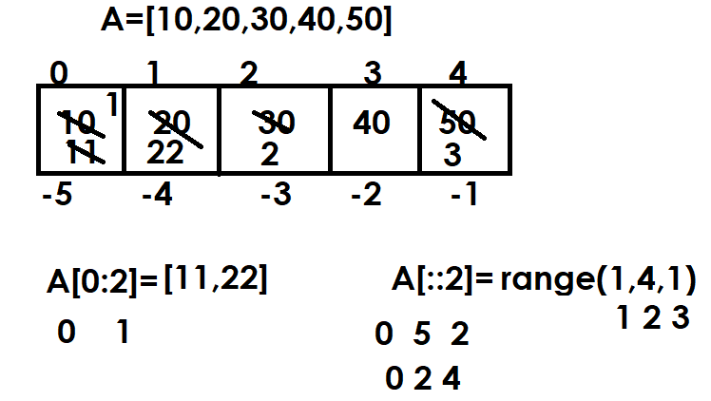

Example
A=[10,20,30,40,50,60,70,80,90,100]
print(A)
A[:3]=[1,2,3]
print(A)
A[-3:]=[8,9,10]
print(A)
A[3:-3]=[4,5,6,7]
print(A)
A[::2]=[10,20,30,40,50]
print(A)
A[::-1]=[0,0,0,0,0,0,0,0,0,0]
print(A)
A[::-2]=[1,2,3,4,5]
print(A)

Output
[10, 20, 30, 40, 50, 60, 70, 80, 90, 100]
[1, 2, 3, 40, 50, 60, 70, 80, 90, 100]
[1, 2, 3, 40, 50, 60, 70, 8, 9, 10]
[1, 2, 3, 4, 5, 6, 7, 8, 9, 10]
[10, 2, 20, 4, 30, 6, 40, 8, 50, 10]
[0, 0, 0, 0, 0, 0, 0, 0, 0, 0]
[0, 5, 0, 4, 0, 3, 0, 2, 0, 1]

Example:
# Write a program swap first 2 values with last 2 values

A=[10,20,30,40,50,60,70]
print(f'Before Swaping {A}')
A[:2],A[-2:]=A[-2:],A[:2]
print(f'After Swaping {A}')

Output
Before Swaping [10, 20, 30, 40, 50, 60, 70]
After Swaping [60, 70, 30, 40, 50, 10, 20]

Deleting elements or values from list
Deleting elements or values from list are done in different ways
- del keyword
- remove() method
- pop() method

“del” keyword
“del” keyword is used for deleting one or more than one value or element.

“del” keyword required 2 things
- index 🡪 for deleting single element or value
- slicing 🡪 for deleting multiple elements or values

using index
“del” keyword uses index for deleting single element or value

Syntax: del list-name[index]

If index within range, it delete element/value
If index is not within range, it raises IndexError

Example:
>>> A=[10,20,30,40,50]
>>> print(A)
[10, 20, 30, 40, 50]
>>> del A[0]
>>> print(A)
[20, 30, 40, 50]
>>> del A[-1]
>>> print(A)
[20, 30, 40]
>>> del A[1]
>>> print(A)
[20, 40]
>>> del A[3]
Traceback (most recent call last):
File "<pyshell#16>", line 1, in <module>
del A[3]
IndexError: list assignment index out of range

Using Slicing
Slicing is used for deleting or removing multiple elements or values

Syntax: del list-name[start:stop:step]

